Wireless Mouse

Cable Free - Wireless Multimedia Travel Keyboard

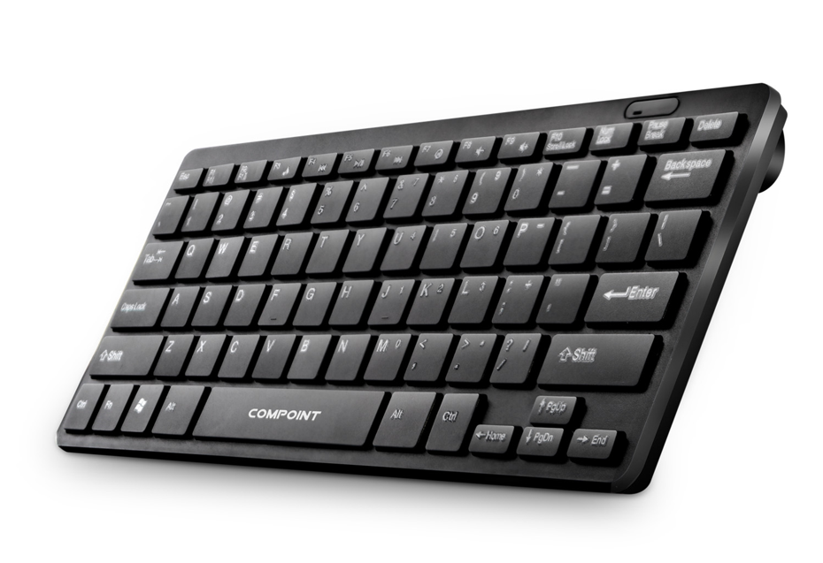

Descrption:

More than just good looks..

The exciting CP-K7070-W is your ideal, lightweight and of course compactwireless keyboard partner for almost any computing device that is fittedwith a standard UsB port. Easier to transport than a regular,full-sizekeyboard and of course without the need to plug in messy cables,cluttering up your workspace.

ldeal for more than just Notebook Computers..

The CP-K7070-W of course is an ideal replacement (or addition) to yourregular keyboard on the desk, lap or in your carry bag. Full multimediacontrol,pleasurable, tactile feedback and of course wireless operation.What's more,being wireless its also a great keyboard for computerprojects such as Raspberry PITM computers,set-top boxes or for exampleAndroid TM mini computers that plug directly into your TV!

Features:

2.4Ghz Wireless Operation

Supplied Wireless USB Nano Adapter

Multimedia Functionality

Low-profile with Tactile Feedback

Lightweight and Compact Design

Plug n' Play for WindowsTM Mac TM

Specifications
- Material：ABS or ABS+Metal
- Working Distance：10m
- Type: 2.4Ghz Wireless
- Certificate: CE FCC ROHS
- Operating Temperature:0℃ to +45℃
- Operating Humidity:10%0 to 85 % RH
- Storage Temperature : -10℃ to +55℃
- Storage Humidity: 5% to 90 % RH

Product Code:
Part number: K7070-W
Barcode: 8400800025975
Size: 285mm*125mm*5mm
Weight: 0.310 kg

